**NUMERACY LESSON GUIDE FOR BABY CLASS 3 – 4 YRS TERM ONE 2023**

ORIENTATION WEEK

CONTENT

* Touring the school
* Recognising / knowing each other
* Watching television
* Playing on the swings and other play materials
* Telling our names
* Taking care of property
* Identifying and naming common shapes

**WEEK TWO**

**Theme** : Shapes

**LESSON I**

Shapes ( a circle)

**Activities**

* Naming the shape
* Recognising and identifying the shape
* Pasting the shape

**WEEK TWO**

**LESSON 2**

**Shapes**

**Activities**

* Telling the shapes
* Shading the shape
* Observing and naming the shape
* Shading a circle

Lesson 3

Shapes

**Activities**

* Identifying and naming the shape
* Recognising the formation of a circle
* Tracing

**Lesson 4**

* Shapes a triangle

**Activities**

* Sorting shapes
* Naming shapes
* Recognising a triangle
* Shading a triangle

**WEEK THREE**

**LESSON 1**

Shapes

Activities

* Sorting shapes
* Naming shapes
* Counting sides of a triangle
* Tracing a triangle

**Lessons 2**

Pasting an oval

**Activities**

* Singing a song about shapes. ( 1 know my shapes)
* Recognising and naming shapes.
* Telling the shape
* Pasting the shape (an oval)

**WEEK THREE**

**LESSON 3**

Shapes

**Activities**

* Recognising the formation of an oval
* Telling the shape
* Sorting shapes
* Shading and tracing an oval

**Lesson 4**

Shading a square

**Activities**

* Naming shapes
* Sorting shapes
* Comparing shapes
* Shading

**WEEK FOUR**

**LESSON 1**

Shapes

**Activities**

* Sorting shapes
* Tracing shapes
* Naming shapes
* Tracing a square

**WEEK FOUR**

**LESSON 2**

**Activities**

* Sorting shapes
* Recognising shapes
* Telling or naming shapes orally
* Matching the same shapes

Shapes

LESSON 3

Shapes

**Activities**

* Identifying and naming the shape
* Sorting shapes
* Comparing
* Shading

**WEEK FOUR**

**LESSON 4**

Shapes

**Activities**

* Naming the shape
* Tracing the shape

**WEEK FIVE**

**LESSON 1**

Shapes

**Activities**

* Sorting shapes
* Naming shapes orally
* Shading

**LESSON 2**

Shapes

**Activities**

* Naming the shape
* Recognising the shape
* Tracing the shape

**WEEK FIVE**

**LESSON 3**

Shapes

**Activities**

* Sorting shapes
* Matching shapes orally
* Naming the shape
* Drawing a zig – zag

**LESSON 4**

Shapes

**Activities**

-Sorting

-Naming

-Recognition

-Matching

**WEEK SIX**

**LESSON 1**

**Activities**

* Sorting shapes
* Matching the same shapes
* Naming
* Circling the same

Circling the same shapes

**WEEK SIX**

**LESSON 2**

**Numbers**

**Activities**

* Recognising numbers(0)
* Counting numbers 0 – 5 orally
* Writing zero

Counting 0 – 5 (orally

|  |  |  |
| --- | --- | --- |
| 0 | 0 | 0 |
|  |  |  |

**Lesson 3**

Numbers

**Activities**

* Counting numbers
* Sorting numbers
* Recognising number 1
* Shading number 1



**=**

**LESSSON 4**

**Number 0 – 5**

**Activities**

* Recognising numbers
* Counting numbers orally
* Copying number l

|  |  |  |
| --- | --- | --- |
| l | l | l |
|  |  |  |

WEEK SEVEN

LESSON 1

Numbers

**Activities**

* Counting
* Sorting or telling numbers
* Shading number 2



 **=**

LESSON 2

**Numbers**

Activities

* Identifying and counting
* Sorting numbers
* Tracing



LESSON 3

Numbers ( 0 – 5 )

**Activities**

* Counting number ( 1 – 5)
* Shading
* Telling number 3



**=**



**WEEK SEVEN**

**LESSON 4**

Numbers (0 – 5)

**Activities**

* Counting number ( 1 – 5)
* Shading
* Telling number 3



**WEEK EIGHT**

**LESSON 1 Numbers ( 0 - 5 )**

**Activities**

* Counting numbers orally
* Sorting
* Shading

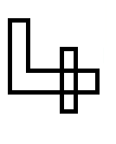

**=**

**WEEK EIGHT**

**LESSON 2**

**Number ( 0 – 5)**

**Activities**

* Recognisng the number
* Counting l – 5 orally
* Sorting numbers
* Tracing the number



LESSON 3

**Activities**

* Recognising the formation
* Sorting
* Counting l – 5 orally
* Writing the number ( ))



WEEK EIGHT

**(Numbers 0 – 5 )**

Activities

* Telling the numbers
* Counting 1 – 5 orally
* Shading numbers





**WEEK NINE**

**LESSON 1**

**TRACING**

**Activities**

* Counting l – 5
* Sorting
* Tracing number 5



**LESSON 2**

**Writing number 5**

**Activities**

* Sorting
* Counting
* Copying number 5

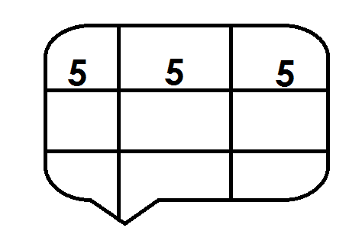

**Week nine**

**Lesson 3**

**Numbers ( 1 – 5 )**

**Activities**

* Counting 1 – 10 orally
* Comparing numbers
* Matching the same

Matching

0 3

I 0

2 I

3 2

LESSON

Numbers

**Activities**

* Recognising the same numbers
* 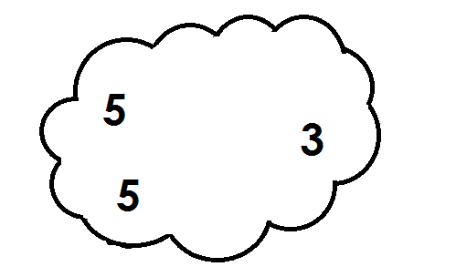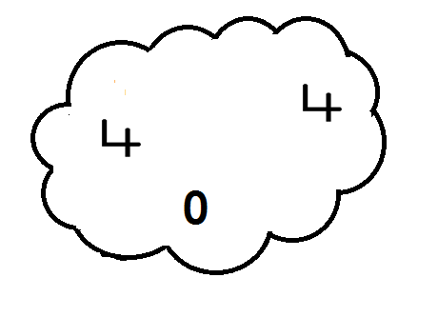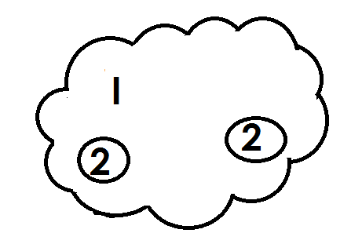Circling the same